STAT 337: ANOVA Activity #1
Lucas Jones
- Work through the practice in the course notes to write out the cell-means and reference-coded hypotheses, estimates, and comparison of estimates for the “CO2 Emissions for 5 Country Groups Example” (pg. 8 - 11).
Once finished with 1, complete the code chunks below and answer Questions 2-5. Once you’ve pasted and tested (i.e,. run code inline to make sure it works) and answered any associated question, change eval = FALSE to eval = TRUE and knit this document.
- Using the code chunk below, read in the CO2_emissions_country_groups.csv dataset. Create an appropriate data visualization, and output summary statistics (Hint: p.10 & 13 of the notes or the beginning of Section 2.2 of the textbook). Add comments describing what each line of code is doing. Make some notes about what you observe in your visualization.
library(tidyverse)
## ── Attaching core tidyverse packages ──────────────────────── tidyverse 2.0.0 ──
## ✔ dplyr 1.1.4 ✔ readr 2.1.6
## ✔ forcats 1.0.1 ✔ stringr 1.6.0
## ✔ ggplot2 4.0.1 ✔ tibble 3.3.1
## ✔ lubridate 1.9.4 ✔ tidyr 1.3.2
## ✔ purrr 1.2.1
## ── Conflicts ────────────────────────────────────────── tidyverse_conflicts() ──
## ✖ dplyr::filter() masks stats::filter()
## ✖ dplyr::lag() masks stats::lag()
## ℹ Use the conflicted package (<http://conflicted.r-lib.org/>) to force all conflicts to become errors
library(mosaic)
## Registered S3 method overwritten by 'mosaic':
## method from
## fortify.SpatialPolygonsDataFrame ggplot2
##
## The 'mosaic' package masks several functions from core packages in order to add
## additional features. The original behavior of these functions should not be affected by this.
##
## Attaching package: 'mosaic'
##
## The following object is masked from 'package:Matrix':
##
## mean
##
## The following objects are masked from 'package:dplyr':
##
## count, do, tally
##
## The following object is masked from 'package:purrr':
##
## cross
##
## The following object is masked from 'package:ggplot2':
##
## stat
##
## The following objects are masked from 'package:stats':
##
## binom.test, cor, cor.test, cov, fivenum, IQR, median, prop.test,
## quantile, sd, t.test, var
##
## The following objects are masked from 'package:base':
##
## max, mean, min, prod, range, sample, sum
library(yarrr)
## Loading required package: jpeg
## Loading required package: BayesFactor
## Loading required package: coda
## ************
## Welcome to BayesFactor 0.9.12-4.7. If you have questions, please contact Richard Morey (richarddmorey@gmail.com).
##
## Type BFManual() to open the manual.
## ************
##
## Attaching package: 'BayesFactor'
##
## The following object is masked from 'package:mosaic':
##
## compare
##
## Loading required package: circlize
## ========================================
## circlize version 0.4.17
## CRAN page: https://cran.r-project.org/package=circlize
## Github page: https://github.com/jokergoo/circlize
## Documentation: https://jokergoo.github.io/circlize_book/book/
##
## If you use it in published research, please cite:
## Gu, Z. circlize implements and enhances circular visualization
## in R. Bioinformatics 2014.
##
## This message can be suppressed by:
## suppressPackageStartupMessages(library(circlize))
## ========================================
##
##
## Attaching package: 'yarrr'
##
## The following object is masked from 'package:ggplot2':
##
## diamonds
emissions5 <- read_csv("CO2_emissions_country_groups.csv")
## Rows: 120 Columns: 4
## ── Column specification ────────────────────────────────────────────────────────
## Delimiter: ","
## chr (2): Country.Name, Country.Code
## dbl (2): Year, CO2.Emissions
##
## ℹ Use `spec()` to retrieve the full column specification for this data.
## ℹ Specify the column types or set `show_col_types = FALSE` to quiet this message.
emissions5 <- emissions5 %>% drop_na()
favstats(CO2.Emissions ~ Country.Code, data = emissions5) #Computes summary stat.
## Country.Code min Q1 median Q3 max mean
## 1 EAP 1.7979242 2.2563410 2.4511929 4.1540989 5.8028410 3.2422600
## 2 ECA 6.7439723 6.9233555 7.4080764 7.7232365 9.6769388 7.4982439
## 3 LAC 2.2027822 2.3174563 2.4727995 2.5893252 2.8896190 2.4848563
## 4 MNA 2.4602369 2.7913448 3.1699638 3.7685371 4.0657783 3.2659236
## 5 SSA 0.8106349 0.8387858 0.8517932 0.8736846 0.9183288 0.8560742
## sd n missing
## 1 1.33500241 24 0
## 2 0.70392745 22 0
## 3 0.19905381 24 0
## 4 0.53373390 24 0
## 5 0.02802744 24 0
ggplot(emissions5, aes(x = Country.Code, y = CO2.Emissions, fill = Country.Code)) + #Creates Boxplot
geom_boxplot(alpha = 0.6) + #Draws boxplot for each group
geom_jitter(width = 0.15, alpha = 0.6) + #adds points
labs(title = "CO2 Emissions by Country Group",
x = "Country Group",
y = "CO2 Emissions") + # add title and axis labes
theme_minimal() #clean theme
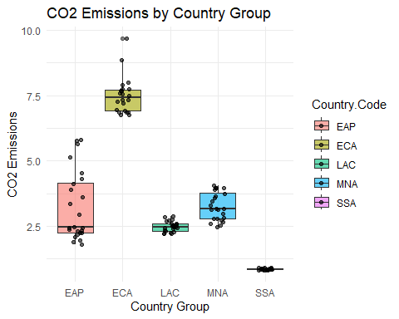
- **The dataset contains emissions grouped by country development level. Developed countries tend to have higher median CO2 emissions.
- Fit the reference coded model and show the summary output
rc_model <- lm(CO2.Emissions ~ Country.Code, data = emissions5) #creates model
summary(rc_model) #display summary
##
## Call:
## lm(formula = CO2.Emissions ~ Country.Code, data = emissions5)
##
## Residuals:
## Min 1Q Median 3Q Max
## -1.44434 -0.29118 -0.00747 0.18755 2.56058
##
## Coefficients:
## Estimate Std. Error t value Pr(>|t|)
## (Intercept) 3.24226 0.14734 22.005 < 2e-16 ***
## Country.CodeECA 4.25598 0.21306 19.976 < 2e-16 ***
## Country.CodeLAC -0.75740 0.20838 -3.635 0.00042 ***
## Country.CodeMNA 0.02366 0.20838 0.114 0.90979
## Country.CodeSSA -2.38619 0.20838 -11.451 < 2e-16 ***
## ---
## Signif. codes: 0 '***' 0.001 '**' 0.01 '*' 0.05 '.' 0.1 ' ' 1
##
## Residual standard error: 0.7218 on 113 degrees of freedom
## Multiple R-squared: 0.9027, Adjusted R-squared: 0.8992
## F-statistic: 261.9 on 4 and 113 DF, p-value: < 2.2e-16
- Fit the cell-means model and show the summary output
cm_model <- lm(CO2.Emissions ~ Country.Code -1, data = emissions5) # fit cell-mesns model
summary(cm_model) # show summary
##
## Call:
## lm(formula = CO2.Emissions ~ Country.Code - 1, data = emissions5)
##
## Residuals:
## Min 1Q Median 3Q Max
## -1.44434 -0.29118 -0.00747 0.18755 2.56058
##
## Coefficients:
## Estimate Std. Error t value Pr(>|t|)
## Country.CodeEAP 3.2423 0.1473 22.00 < 2e-16 ***
## Country.CodeECA 7.4982 0.1539 48.72 < 2e-16 ***
## Country.CodeLAC 2.4849 0.1473 16.86 < 2e-16 ***
## Country.CodeMNA 3.2659 0.1473 22.16 < 2e-16 ***
## Country.CodeSSA 0.8561 0.1473 5.81 5.86e-08 ***
## ---
## Signif. codes: 0 '***' 0.001 '**' 0.01 '*' 0.05 '.' 0.1 ' ' 1
##
## Residual standard error: 0.7218 on 113 degrees of freedom
## Multiple R-squared: 0.9701, Adjusted R-squared: 0.9688
## F-statistic: 733.5 on 5 and 113 DF, p-value: < 2.2e-16
- Create a term plot — choose whichever you like better from the two plots given below. Report the plot and describe in your own words what it shows.
library(effects)
## Loading required package: carData
## Use the command
## lattice::trellis.par.set(effectsTheme())
## to customize lattice options for effects plots.
## See ?effectsTheme for details.
plot(allEffects(cm_model), main = "Term Plot of CO2 Emissions by Country Group", colors=c("steelblue","firebrick"))
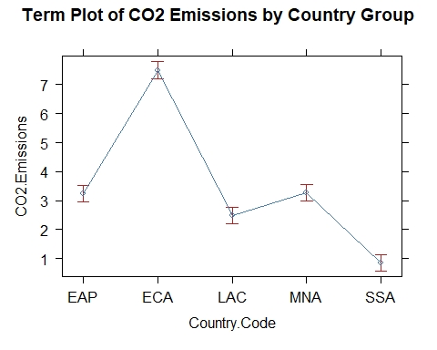
# you will likely need to install ggeffects to run this code
#library(ggeffects)
#ggeffect(<MODEL_FROM_Q5>, terms = "Country.Code")
#plot(ggeffect(<MODEL_FROM_Q5>, terms = "Country.Code"))
- The term plot shows the estimated mean CO2 emissions for each country group based on the cell-means model. Each point is the average emissions for a group, with error bars indicating the spread in the estimate. The plot clearly shows increasing Co2 emissions as country development increases.

